System Requirements

The Examena App can run well both on Windows and MacOS by ensuring that candidates' laptops meet the minimum requirements documented below.
Item | Minimum Requirement | Recommended Requirement
Operating System | Windows 8.1  MacOS 10.15 | Windows 10 or later  MacOS 10.15.7 or later
Memory | 2 GB | 4 GB or more
CPU | 2 Core 1.8 GHz for Win  2 Core 8 GHz for Mac | 4 Core 2.0 GHz or above for Win  4 Core 8 GHz or above for Mac
Hard Drive | 1 GB free space | 5 GB free space or more
Internet* | Bandwidth: >= 5Mbps  Latency: <= 300ms
User Account Type | Administrator privileges are required to install software
*Site for testing bandwidth & latency: https://speedtest.telstra.com/. Examination venues have been selected that meet these requirements.

Please also note the following:
- External monitors will be disabled during any exam sessions. Please disconnect any secondary monitors and ONLY use your primary laptop screen during the sample examination. The use of external monitors will not be possible during the actual examination
- Use your ANZCVS email address ending in “@anzcvs.org.au” to log into the Examena App. If you have another Microsoft Account you will need to log out of this account or open an incognito window in your browser to login to the website. Please see the help guide on the following pages for more information.

Information Guide on Incognito Tabs in Web Browsers

Please find instructions below on how to open an Incognito (InPrivate) Window on common internet Browsers
Open Incognito in Chrome
On Laptop
Just press Ctrl-Shift-N. For opening it on macOS, press Command-Shift-N. Or, you can click on the three vertical dots at the upper right menu and select the New incognito window option from the drop-down list.
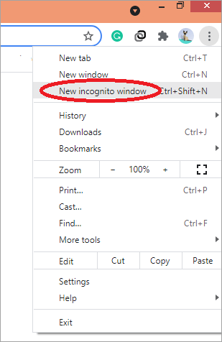

Open Incognito in Apple Safari On Mac

Just click on the File tab and select New Private Window

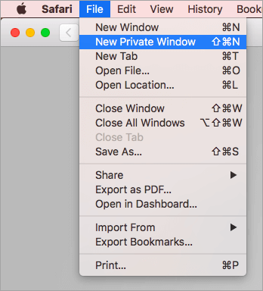

Open Incognito in Microsoft Edge
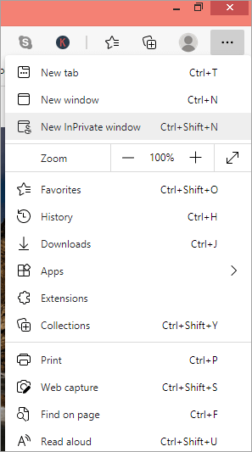
Go to the Edge menu, three horizontal data at the browser’s right hand, and click on it. Select New InPrivate window. Or you can just click Shift + CTRL + N.

Open Incognito in Internet Explorer
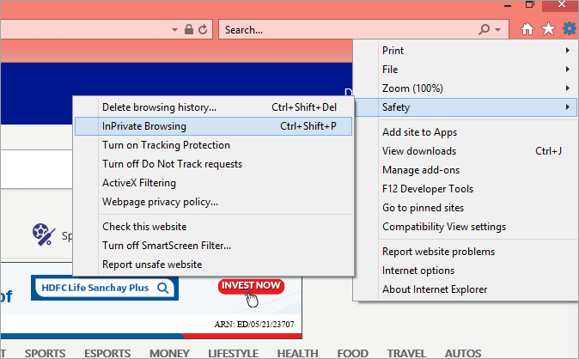
Go to the Gear menu at the top right-hand corner of the browser. Go to the Safety option and click on InPrivate Browsing from the extended menu. Or, you can use the keyboard shortcut Shift + CTRL + P.

Open Incognito in Mozilla Firefox

Click on the three vertical lines upper-right-hand corner to open the Firefox menu. From the dropdown menu, select New Private Window. You can also use the keyboard shortcut Shift + P for macOS and Shift + CTRL + P for Windows and Linux.

